Elizabeth Rogers

Guided Capstone Project Report

The current ticket price at Big Mountain Resort was set by applying a premium to other ticket prices in the region. As we’ve long assumed, however, this is an imperfect strategy, which doesn’t properly align our features with their true value to our customers. We know Big Mountain Resort has more to offer than other resorts in the region, but just what does that mean for predicting our ideal ticket price? A data analysis of the features available at other national resorts, aligned with their respective ticket prices, has helped us see ourselves within the larger whole of national resorts and it’s helped us to envision a more ideal position for our resort in the future.

Our data analysis has shown, through a combination of Linear Regression and Random Forest Regression models, that the features which most positively correlate to resort ticket price, nationally, are: the number of fast quads, the number of runs, the amount of snow-making area, the total vertical drop, and the total number of chairs. Below, you can also see that BMR is well-positioned in these highly coveted categories.

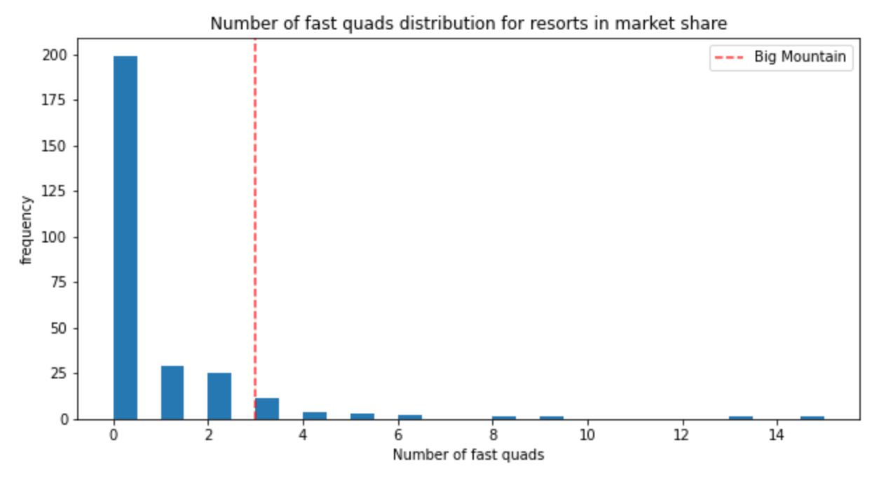

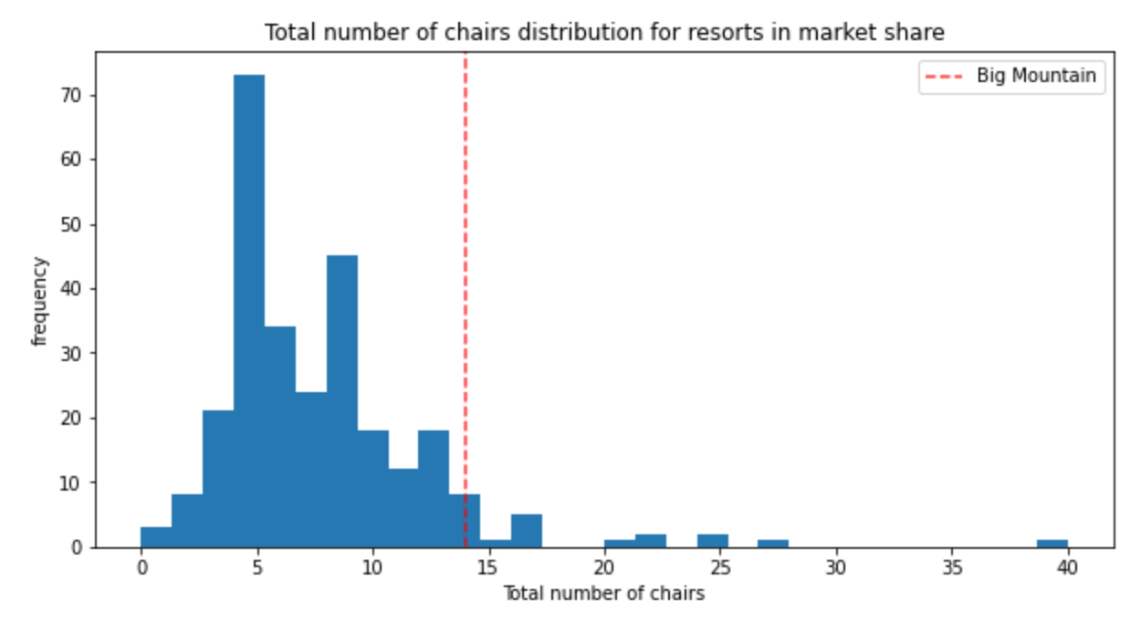

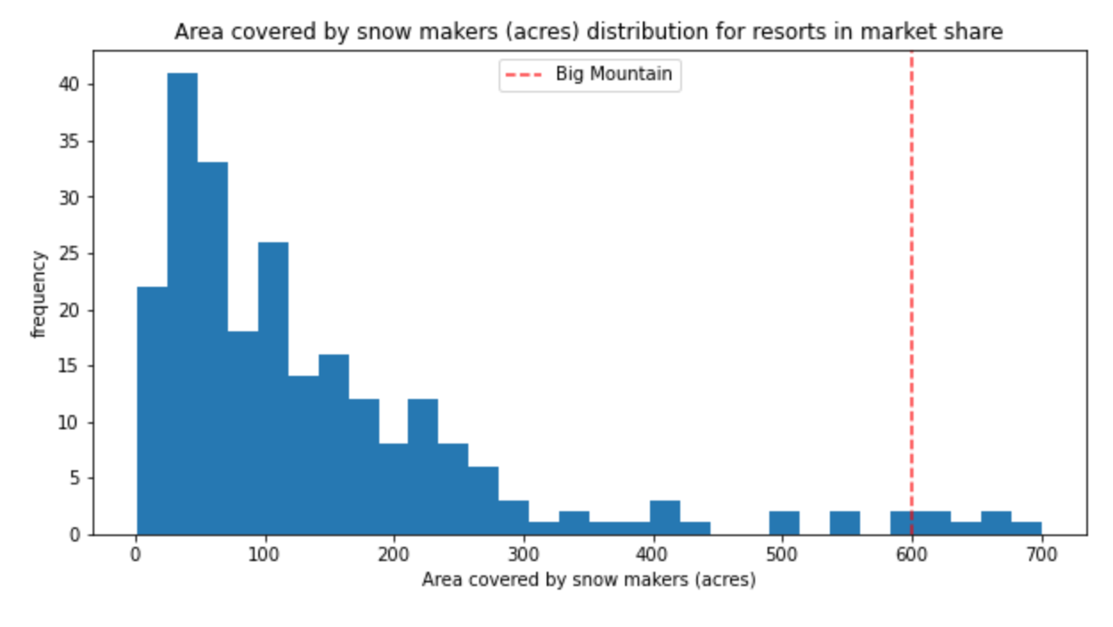

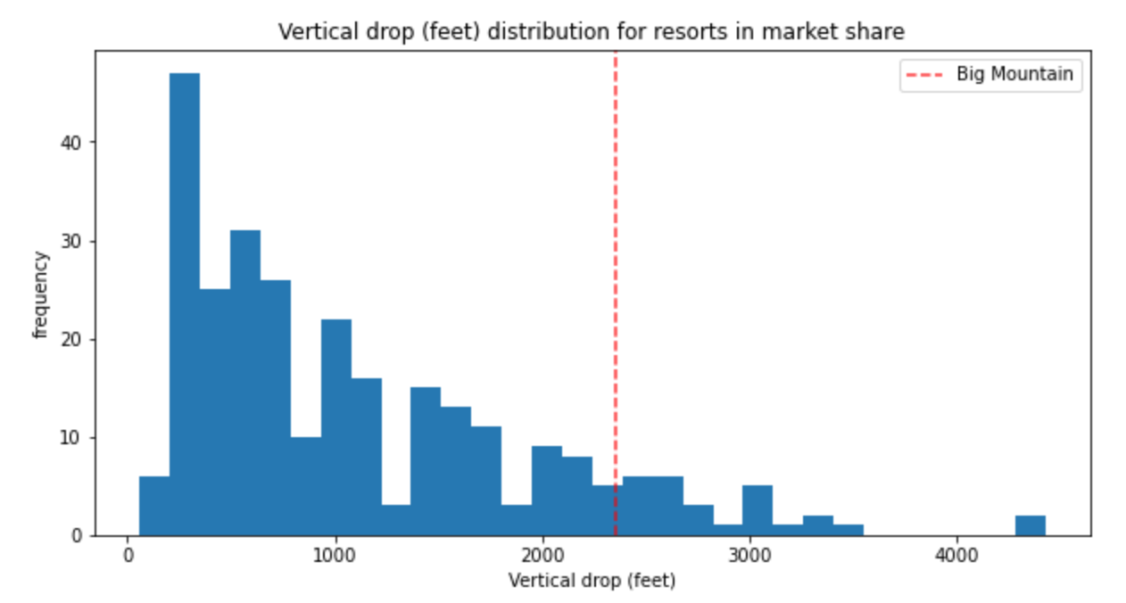

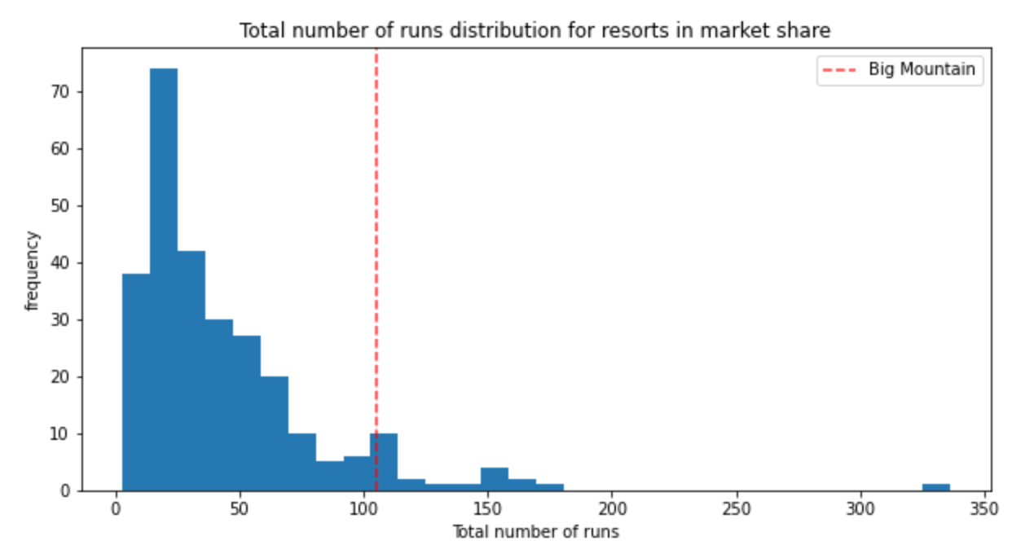

After looking at these figures, it might not come as a surprise to learn BMR’s many positive features indicate, via machine learning, that our current pricing strategy is highly imperfect, and that we could actually stand to increase our current prices sizably. In fact, based on our most effective Random Forest Regression Model, when factoring in what BMR has to offer relative to its competitors and their pricing, we find that BMR could conceivably raise its ticket price from $81 to as much as $95.87! This prediction comes with a $10.39 margin of expected error, however, which makes a conservative estimate for BMR’s ideal ticket price closer to $85.48. Even using the more conservative estimate, BMR stands to increase its revenues sizably. A price increase of $5.48 per ticket, assuming 350,000 visitors per season, with each visitor staying for 5 days, would mean an increased revenue of $9,590,000.

The executives have been considering some changes to BMR’s features going forward. Two of those scenarios, when matched to our model, would see benefits, while two would not. First, our price prediction model indicates that closing one run permanently would actually not negatively affect the ticket price set above; however, closing more runs would drop this ideal 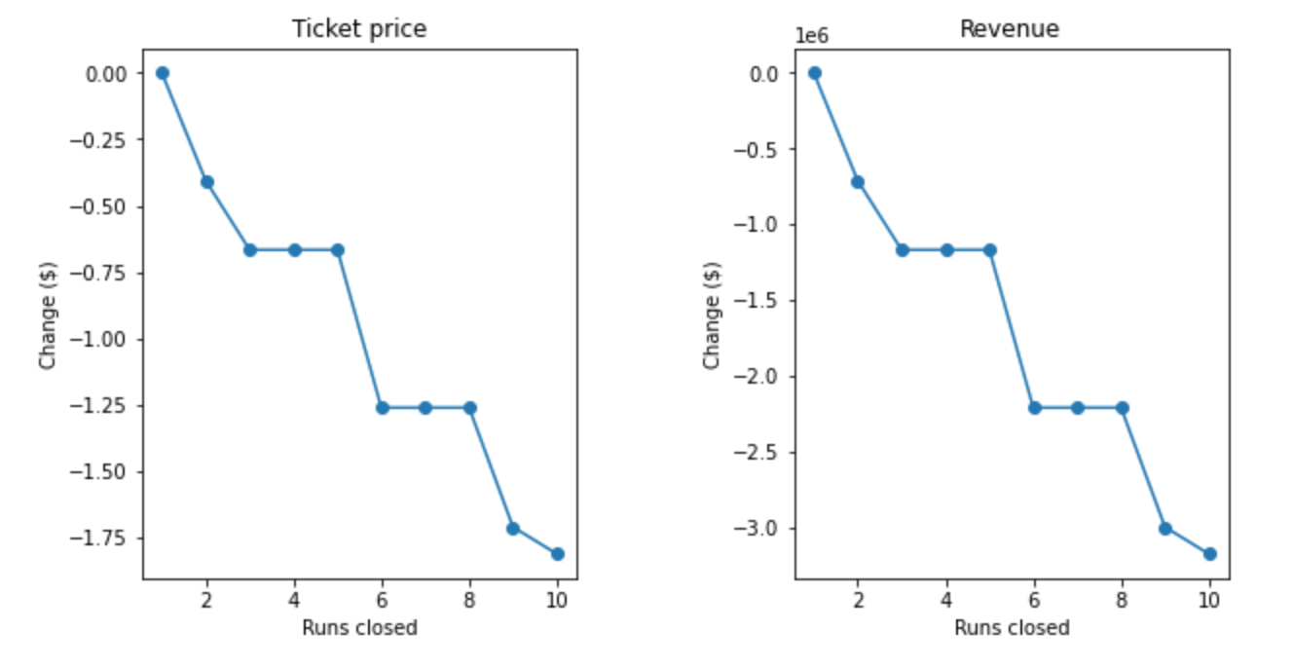price. These price drops are visualized in the graph below.

Next, extending a run by 150 feet in order to raise the vertical drop value, which we’ve just seen is a positive predictor of ticket price, while adding an additional chairlift and no additional snowmaking, increases the projected ticket price by $1.99. This ticket increase, assuming a season of 350,000 visitors all paying for 5 days’ worth of tickets, would indeed more than cover the price of the additional chairlift. This scenario would amount to an expected total gain of $3,474,638, compared to the $1,540,000 projected cost of a new chairlift. Adding two additional acres of snowmaking to this scenario would not, however, increase the target ticket price by any amount.

The final scenario, adding .2 miles to the current longest run and an additional 4 acres of snowmaking, is similarly not projected to make any difference with regard to the supported ticket price, and is thus not supported by our model.